Welcome!
Date
Name
Spouse
Address
City
State Zip _________
Email

Please Contact By
❑ Card  Phone  Visit

Telephone Best Time to Call
Home ______________
Work ______________

Guest: First Time Second Time
Are you a church member: yes no
Church
City, State

Circle Appropriate Age/Grade Group(s)
Preschool: Ages: B-1 2-3 4-5
Children: Grades: K 1 2 3 4 5 6
Youth: Grades: 7 8 9 10 11 12
Adults: Ages:18-29 30s 40s 50s 60s+

How did you learn about our church?
Newspaper Friend Yellow Pages Mail
Other

I am a guest of:

New in the Community? Yes No
Names & ages of children at home

Weekly Service & Activity Schedule

November 8, 2015

9:45 a.m. Sunday School
11:00 a.m. Worship Service
6:00 p.m. Evening Worship

Week of November 8, 2015
Wednesday 6:30 pm Meal/ Adult Bible Study
Thursday 10:00 am Adult Fellowship

Upcoming Events

November
14………………………………………………….Harvest Stew
15……………………………………….……Business Meeting
21………………………………….Merrell/Edwards Wedding
26………………………………………..………..Thanksgiving
December
Nov 29 – Dec 5…..Week of Prayer – Lottie Moon Missions



Don’t miss Harvest Stew!
The gospel music is great; the food is delicious; the games are fun; and the blessings are overflowing! Come and bring lots of friends and neighbors!
Check out the Bulletin insert


Kenny & Rachel
are
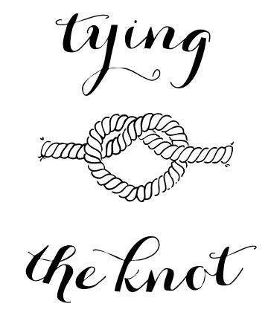
Saturday, Nov 21, 2015

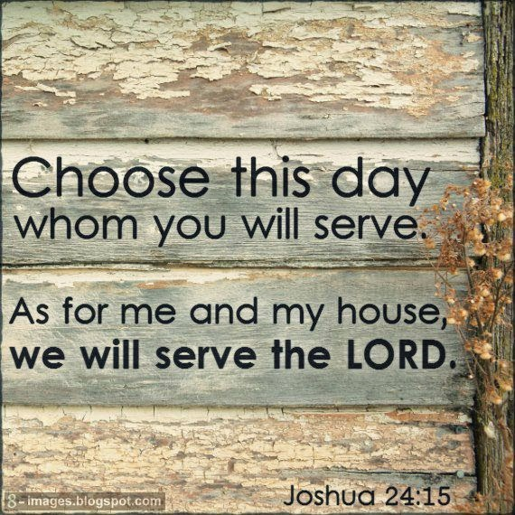

Knobbs Springs Baptist Church

November 8, 2015

Church Information:

KnobbsSpringsBC.com KnobbsSpringsBaptist@gmail.com

1662 CR 305, McDade, Texas 78650 512-273-2743

David Atwood, Pastor Cell 512-470-5098
Home 512-856-2819
Patti Radford, Office Manager Cell 512-968-7821

